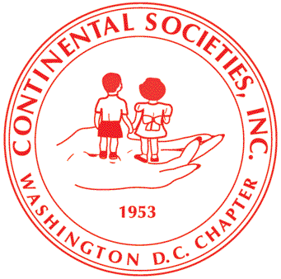
Continental Societies, Incorporated
Washington DC Chapter
633 Pennsylvania Avenue, NW, Washington, DC 20004
“Our Children, Our Commitment, Our Concern”

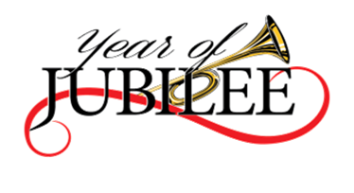
March 20, 2017

Name
Street Address
City, State Postal Code
Dear ____________:
The Continental Societies, Inc. Washington D.C. Chapter is a 501(c)(3) non-profit public service organization whose mission is to advance the welfare of underserved children. We provide community-based programs for students in elementary, middle and high schools in the Washington Metropolitan area. Continental Societies has been actively devoted to this goal for more than 60 years providing assistance in the areas of health, education, employment, recreation, and the arts and humanities.
Last year, we served more than 6,000 students in programs ranging from dental screenings to scholarships. We contributed approximately $26,000 in in-kind services to HEER Plus (Health, Education, Employment and Recreation) we also provided $7,000 in scholarships, and $3,000 in in-kind value for tutorial/mentoring services.
We ask that you consider supporting our organization in meeting our goal to more than double the students that we supported last year. Your donation or sponsorship will help ensure the success for the students that benefit from our programs. Please see the attached form and instructions on how to make a donation and information regarding our annual gala.
We hope you can join us for our Annual Gala on October 28, 2017 and will also consider supporting our mission through a sponsorship. Please let us know by June 1, 2017 if you are interested in being a featured sponsor.
For additional information please contact Ms. Denise Shelton, Marketplace Chairperson at (202) 246-9287, or email dmshelton3@comcast.net, or visit our website at www.dccontinentals.com. We look forward to hearing from you.
Sincerely,
Denise Shelton
Denise Shelton
Chairperson
Margo H. Briggs
President
Attachment: Sponsor Form

Edna Lee Moffit
National President
Margo H. Briggs
President
C. Lillette Campbell
1st Vice President
V. Anne Shepherd
2nd Vice President
Cathy A. Husbands
Recording Secretary
Xzaquoinette Y. Warrick
Corresponding Secretary
Phyllis Yates-Manigault
Financial Secretary
Joyce Z. Pascal-Kilgore
Treasurer
Aurelia Martin
Historian
Ethel B. Lawhon
Chaplain
Denise Shelton
Sergeant-at-Arms
Eunice Cherry
Public Relations Officer
Essie G. Page
Parliamentarian
Venida Y. Hamilton
Immediate Past President
Advisory Board
Dr. Vance Moss
Dr. Vince Moss
Honorable Judge Mary Terrell
Honorary Members
Artis Hampshire-Cowan
Alexis M. Herman

